**ACTIVITY 1**

**Individual work !**

1. Draw the DOM tree for the HTML code below :

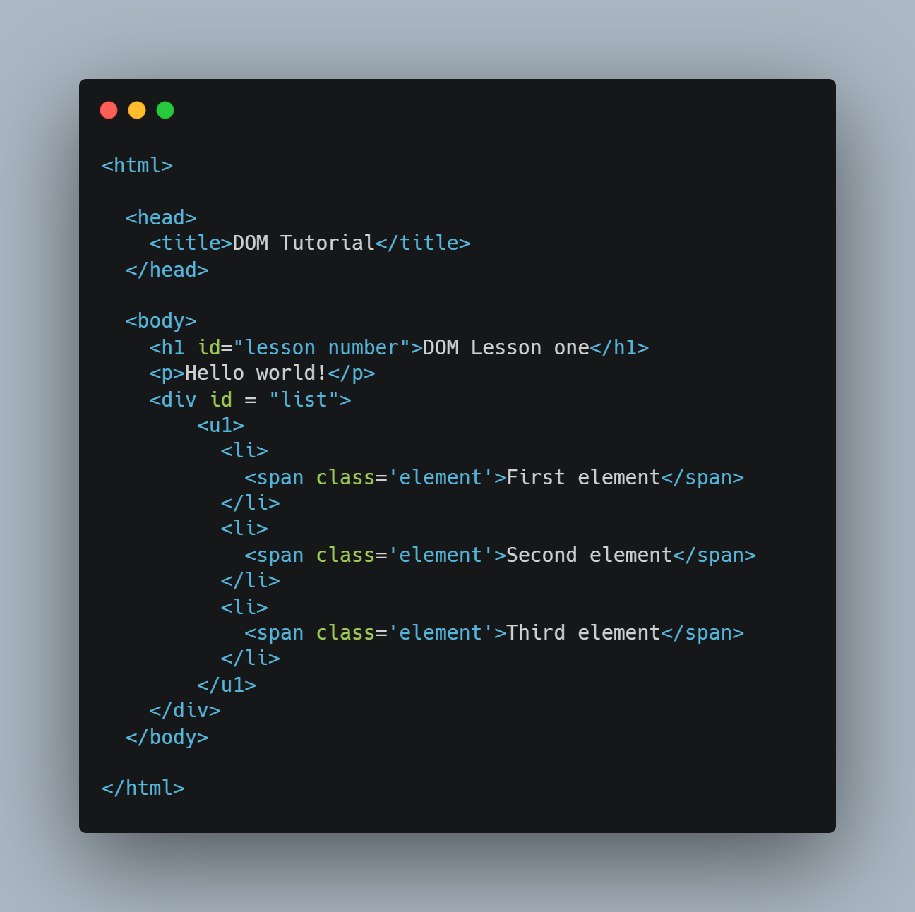

1. **Answer the questions :**

|  |  |
| --- | --- |
| How many **children** does the <h1> node have | Doesn’t have |
| How many **children** does the <head> node have | 5 |
| How many **siblings** does the first <li> node have | 3 |
| Who is the **parent** of the second <span> node | 3 |
| Who is the **parent** of the <ul> node | <div id = “list”> <div> |
| Who is the **first child** of the <body> node | <h1 id =”lesson number”> <h1> |
| How many **children** does the <body> node have | 4 |
| How many **siblings** does the <ul> sibling have | Doesn’t have |
| What is the **root** **node**, does it have parents |  |